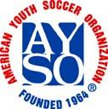 | Sponsored by AYSO Region 16 Torrance, California  2025 AYSO All American Turkey Tournament  Team Application Form | 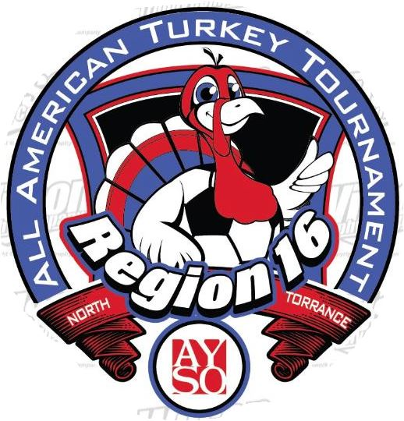
Application Instructions

Applications are now being accepted for entrance into the AYSO All-American Tournament.
The deadline for entering the tournament is Nov 7th, 2025. Applications accepted by that date will be given priority for acceptance into the tournament; all others will be accepted based on any available openings.
Applications will be accepted on a first-come basis, based on a completed application. To be considered complete, your application must include the following:
1 Must fill out the online application google form to initiate
- Team Application Form, signed by the Head Coach and the Regional Commissioner.
- Team Roster Form signed by your Regional Commissioner.
Roster Notes:
- Alternatively, a Blue sombrero Roster form will be accepted, however it must include the names of the Head Coach and Assistant Coach and be signed by your Regional Commissioner.
- Cub & Alliance Teams must have ID’s and Roster. 3 guest players max.
- Roster changes will be allowed until Team Check-in; after that, no roster changes. All roster changes must be approved by your Regional Commissioner.
- Rosters must be composed solely of players who were registered and played in the AYSO 2025 primary program.
- Up to 3 guest players may be added to your roster from a neighboring AYSO Region. In this case, the guest player’s Regional Commissioner must sign the roster.
- Player roster limits are as follows:
U-19/U-16 18 players max 11-v-11 play
U-13-14 15 players max 11-v-11 play
U-11-12 12 players max 9-v-9 play
U-U8 09-10 10 players max 7-v-7 play
- The completed Referee Form signed by your Regional Referee Administrator (if you’re not planning to bring referees, just check the box on the Referee Form and return it without the RRA signature).
- A single region checks for the total amount of the Team Entry Fee and the Referee Commitment Fee.
Team fees are Age Division Team Entry Fee Referee Fee Total Fees
U-19/U-16 $700 $300 $1000
U-13-14 $650 $300 $950
U-11-12 $550 $300 $850
U-10 $500 $300 $800
U-8 $300 $300 $600
Send your completed application and regional check to: Tournament Registrar
2023 AYSO All-American Turkey Tournament
15338 Cranbrook Avenue
Lawndale, California, 90260
Or Email to Turkeytournament@aysoregion.org
If accepted, it will be assumed that you intend for your team to play the entire tournament, and to return, if necessary, on the rainout alternative dates (if becomes necessary).
If your application is not accepted, you will be offered the opportunity to be placed on a waiting list, or if you prefer, we will return your application to you within 48 hours of your decision.
Refund: if you withdraw your application 21 or more days from the start of the tournament, a full refund will be issued. If you withdraw after that time, we will only issue a refund if a replacement team can be found, less any cost to register that replacement team.
All information about the tournament can be obtained by visiting our website at www.ayso16.org
Please note that e-mail and the internet will be the primary means of communication for this tournament.
We will be sending out information via email newsletter once your application is received. In the meantime, if you have any further questions, you may contact us as follows: Paul Lopez (424) 645-9683
E-mail turkeytournament@aysoregion16.org

2025 AYSO All American Turkey Tournament

Team Application Form
 |  |  |  |  |  |  |  |  |  |  |  |  |  |  |  |  |  |  |  |  |  |  |  |  |  |  |  |  | Application Date:
Section: |  |  |  |  |  |  |  | Area: |  |  |  |  |  |  | Region #: |  |  |  |  |  |  | Region Name:
Team Name:
Boys |  |  |  |  |  |  | Girls
Age Division: |  |  |  |  |  |  | U-9 |  |  |  |  |  | U-10 |  |  | U-11 |  |  | U-12 |  |  |  |  | U-13 |  |  |  |  |  |  | U-14 |  |  |  |  |  | U16 |  |  | U19
Contact Information
Coach Name: |  |  |  |  |  |  |  |  |  |  |  |  |  |  |  |  |  |  |  | Asst. Coach Name:
E-mail: |  |  |  |  |  |  |  |  |  |  |  |  |  |  |  |  |  |  |  | E-mail:
Mailing Address: |  |  |  |  |  |  |  |  |  |  |  |  |  |  |  |  |  |  |  | Mailing Address:
City/State/Zip: |  |  |  |  |  |  |  |  |  |  |  |  |  |  |  |  |  |  |  | City/State/Zip:
Evening Phone Number: |  |  |  |  |  |  |  |  |  |  |  |  |  |  |  |  |  |  |  | Evening Phone Number:
Emergency Phone Number: |  |  |  |  |  |  |  |  |  |  |  |  |  |  |  |  |  |  |  | Emergency Phone Number:
AYSO ID#: |  |  |  |  |  |  |  |  |  |  |  |  |  |  |  |  |  |  |  | AYSO ID#
Training Level : |  |  |  |  |  |  |  |  |  |  |  |  |  |  |  |  |  |  |  | Training Level :
Safe Haven Date: |  |  |  |  |  |  |  |  |  |  |  |  |  |  |  |  |  |  |  | Safe Haven Date:
Team Rating Criteria:
1) We are an Allstar/Select Team, the only one from our Region. |  |  |  |  | Yes |  |  | No
2) We are an Allstar/Select Team, one of |  | teams in this age division from our Region. |  |  | Yes |  |  | No
3) We are a fall primary program team. |  |  |  |  | Yes |  |  | No
4) My team competitive rating between 1 (low) and 10 (high) is
5) The average age of our players as of January 1, 2025 is
Team Head Coach Approval:
 | Yes, I have read the tournament rules and I promise to abide by them. I also am committed to returning on the alternative dates should the tournament be rescheduled due to inclement weather, etc.
 | Yes, I understand that this is a 3-day tournament and that the medal round games is on the second day. I hereby notify you that I will NOT be able to complete the tournament for the following reason:
Coach Signature
Regional Commissioner Approval: Yes, the above team has my permission to attend the 2018 AYSO All-American Turkey Tournament. Please report any behavior problems to me immediately. I understand that players from outside my Region (Guest Players) will need approval as well
from the Guest Player Regional Commissioner. I hereby approve the addition of |  |  |  |  |  |  |  | Guest Players for this team.
Print Name |  |  |  | Signature (in red or blue ink only, please)
Email: |  |  |  | Best Phone:
The Referee Refund Check should be mailed to:
AYSO Region #
Send Check to Treasurer:
Mailing Address:

